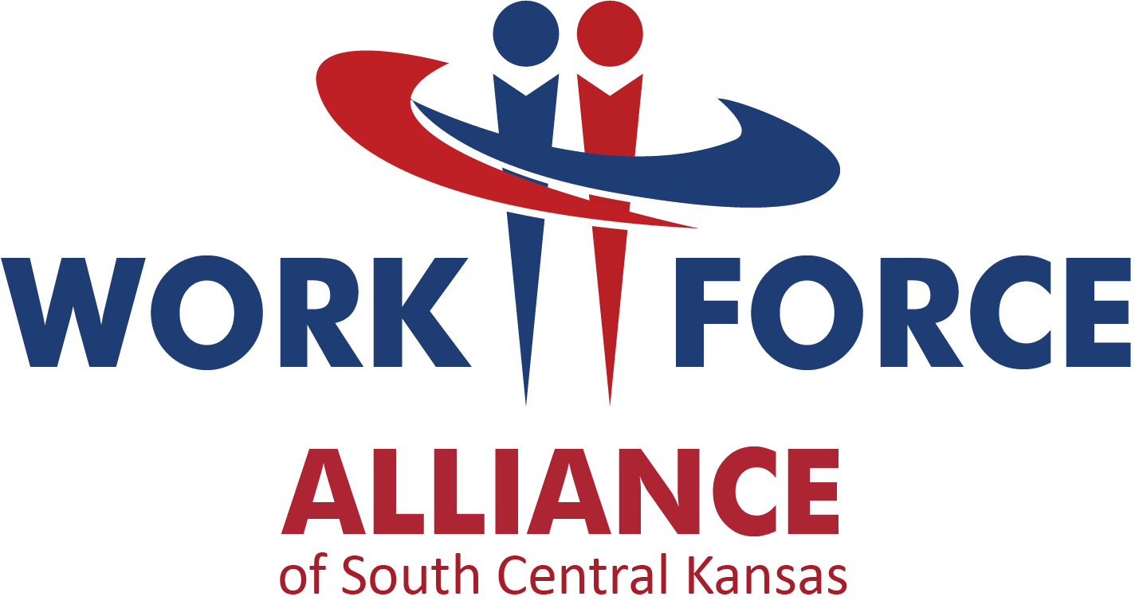

Conflict of Interest Disclosure
Form for the RFP of the
Operation of the WIOA Youth Program in South Central KS

NAME OF ORGANIZATION: _________________________

- Please list any and all individuals who assisted, contributed and/or substantially influenced the writing, research, preparation, and submission of this proposal:

- Are any of the individuals involved in the writing, preparation, research, and/or submission of this proposal members of the Local Workforce Development Board, Chief Elected Officials Board, or Workforce Alliance staff? If yes, please list those individuals:

- Were any of the individuals involved in the writing, preparation, research, and/or submission of this proposal, employed by the Workforce Alliance within the last twelve (12) months? If yes, please list those individuals:

- If applicable, please describe any additional Conflict of Interest disclosures below.

I certify that the organization listed above has no conflict of interest as stated in the RFP.

Name: _________________________________ Title:______________________________

Signature: _______________________________ Date: ______________________________

